Semester | T.E. Semester V– BIOM
Subject | Biomedical Digital Signal Processing
Subject Professor In-charge | Prof. Geetha Narayanan
Student Name | Rehan Raza Shaikh
Roll Number | 24105A0037
Grade and Subject Teacher’s Signature

Week 1 Submission
Project Title | Phonocardiogram (PCG)
Weekly Objective | Signal Operation  - Time Reversal  - Odd/Even Separation  - Delay  - Scaling
Key concepts learned | Use of google colab  Uploading of datasets  Sampling of data
Work Completed | Basic signal operation
Code | import sys  !{sys.executable} -m pip install wfdb  import wfdb  # The base filename is '100' for 100.hea, 100.dat, 100.atr  record_name = '100'  # Read the record. This will automatically look for 100.hea and 100.dat  record = wfdb.rdrecord(record_name)  # Display information about the record  display(record.__dict__)  # Display the first few samples of the signal  print("\nFirst 5 samples of the signal:")  display(record.p_signal[:5])  Signal Sample  import matplotlib.pyplot as plt  # Define the start and end samples for the segment you want to view  start_sample = 0  end_sample = 200 # Further reduced to view an even smaller segment  # Assuming it's an ECG signal and we want to plot the first lead  # You might need to adjust '0' if your signal has multiple leads and you want a different one  plt.figure(figsize=(15, 6))  plt.plot(record.p_signal[start_sample:end_sample, 0])  plt.title(f'Signal from {record_name} (Lead {record.sig_name[0]}) - Samples {start_sample} to {end_sample}')  plt.xlabel('Sample Number')  plt.ylabel(f'Amplitude ({record.units[0]})')  plt.grid(True)  plt.show()  Time Reversal  # Get the segment of the signal we were working with  signal_segment = record.p_signal[start_sample:end_sample, 0]  # Reverse the signal segment  reversed_signal_segment = signal_segment[::-1]  plt.figure(figsize=(15, 6))  plt.plot(reversed_signal_segment)  plt.title(f'Reversed Signal Segment from {record_name} (Lead {record.sig_name[0]}) - Samples {start_sample} to {end_sample}')  plt.xlabel('Reversed Sample Index')  plt.ylabel(f'Amplitude ({record.units[0]})')  plt.grid(True)  plt.show()  Odd/Even Separation  # Ensure we have the latest signal segment  signal_segment_for_separation = record.p_signal[start_sample:end_sample, 0]  # Separate into even and odd indexed samples  even_samples = signal_segment_for_separation[::2]  odd_samples = signal_segment_for_separation[1::2]  # Create a figure with two subplots  plt.figure(figsize=(18, 6))  # Subplot for Even Samples  plt.subplot(1, 2, 1) # 1 row, 2 columns, first plot  plt.plot(even_samples)  plt.title(f'Even Indexed Samples (Lead {record.sig_name[0]})')  plt.xlabel('Even Sample Index')  plt.ylabel(f'Amplitude ({record.units[0]})')  plt.grid(True)  # Subplot for Odd Samples  plt.subplot(1, 2, 2) # 1 row, 2 columns, second plot  plt.plot(odd_samples)  plt.title(f'Odd Indexed Samples (Lead {record.sig_name[0]})')  plt.xlabel('Odd Sample Index')  plt.ylabel(f'Amplitude ({record.units[0]})')  plt.grid(True)  plt.tight_layout() # Adjust layout to prevent overlapping titles/labels  plt.show()  Signal Delay  import numpy as np  # Get the segment of the signal we were working with  signal_segment_for_delay = record.p_signal[start_sample:end_sample, 0]  # Define the delay amount in samples  delay_samples = 20 # You can change this value  # Create a delayed signal by shifting the original.  # For simplicity, we'll pad with zeros at the beginning.  delayed_signal_segment = np.zeros_like(signal_segment_for_delay)  if delay_samples < len(signal_segment_for_delay):  delayed_signal_segment[delay_samples:] = signal_segment_for_delay[:-delay_samples]  # Plot the original and delayed signals  plt.figure(figsize=(15, 6))  plt.plot(signal_segment_for_delay, label='Original Signal Segment')  plt.plot(delayed_signal_segment, label=f'Delayed Signal (by {delay_samples} samples)', linestyle='--')  plt.title(f'Original vs. Delayed Signal Segment from {record_name} (Lead {record.sig_name[0]})')  plt.xlabel('Sample Index')  plt.ylabel(f'Amplitude ({record.units[0]})')  plt.grid(True)  plt.legend()  plt.show()  Signal Scaling  # Get the segment of the signal we were working with  signal_segment_for_scaling = record.p_signal[start_sample:end_sample, 0]  # Define the scaling factor  scaling_factor = 1.5 # You can change this value (e.g., 0.5 for reduction, 2.0 for amplification)  # Apply the scaling factor to the signal segment  scaled_signal_segment = signal_segment_for_scaling * scaling_factor  # Plot the original and scaled signals  plt.figure(figsize=(15, 6))  plt.plot(signal_segment_for_scaling, label='Original Signal Segment')  plt.plot(scaled_signal_segment, label=f'Scaled Signal (Factor: {scaling_factor})', linestyle='--')  plt.title(f'Original vs. Scaled Signal Segment from {record_name} (Lead {record.sig_name[0]})')  plt.xlabel('Sample Index')  plt.ylabel(f'Amplitude ({record.units[0]})')  plt.grid(True)  plt.legend()  plt.show()
Evidence of Progress/Results | 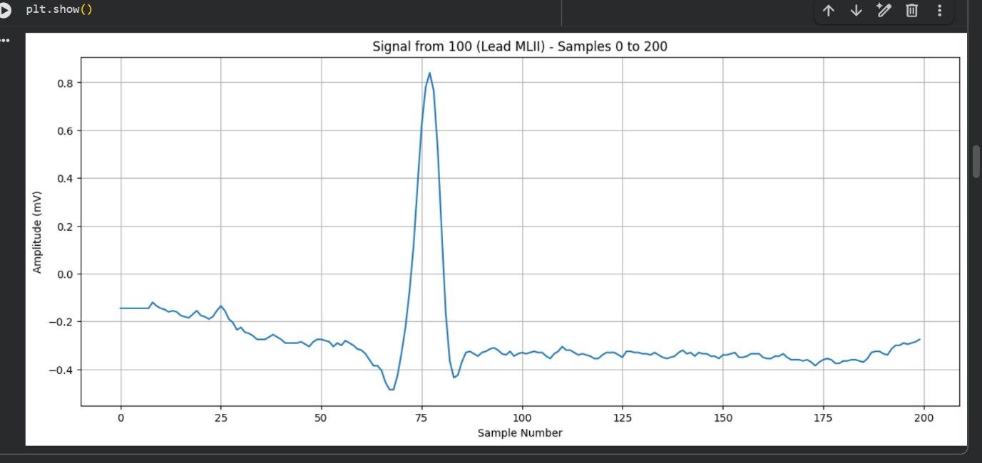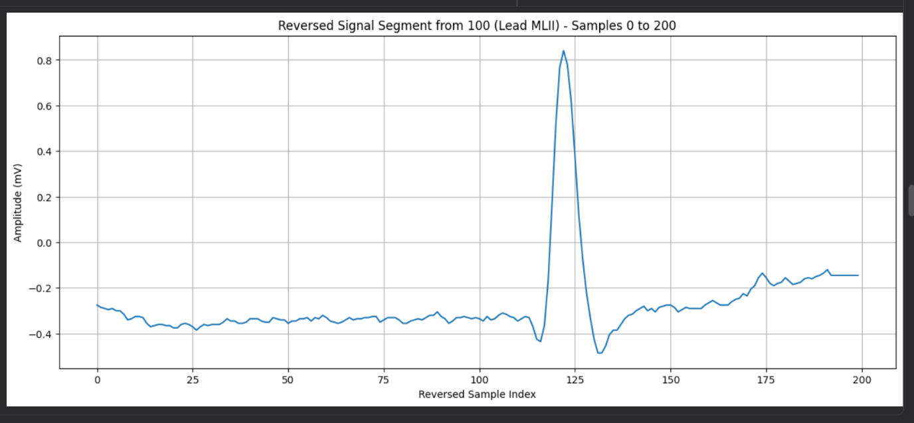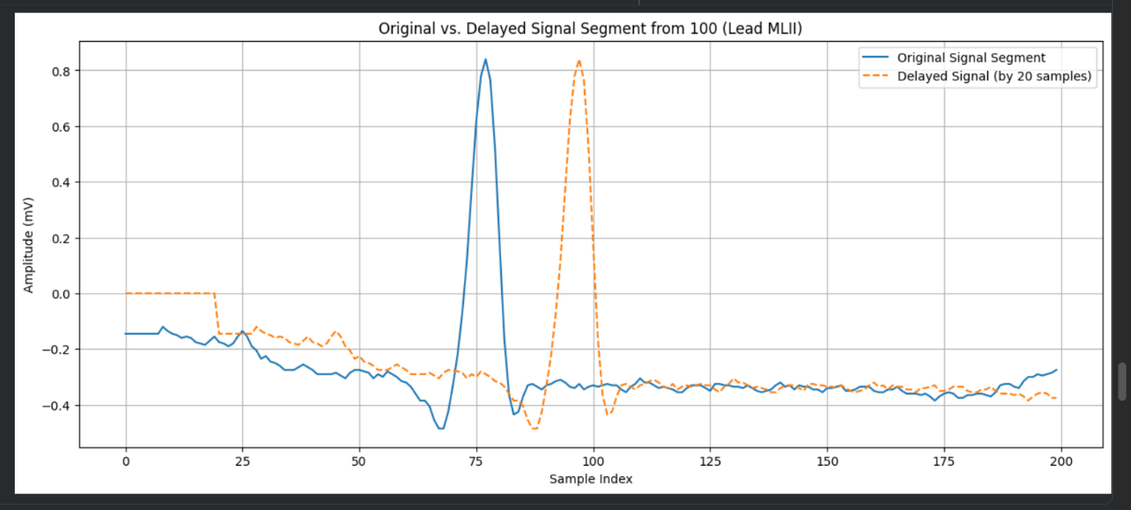  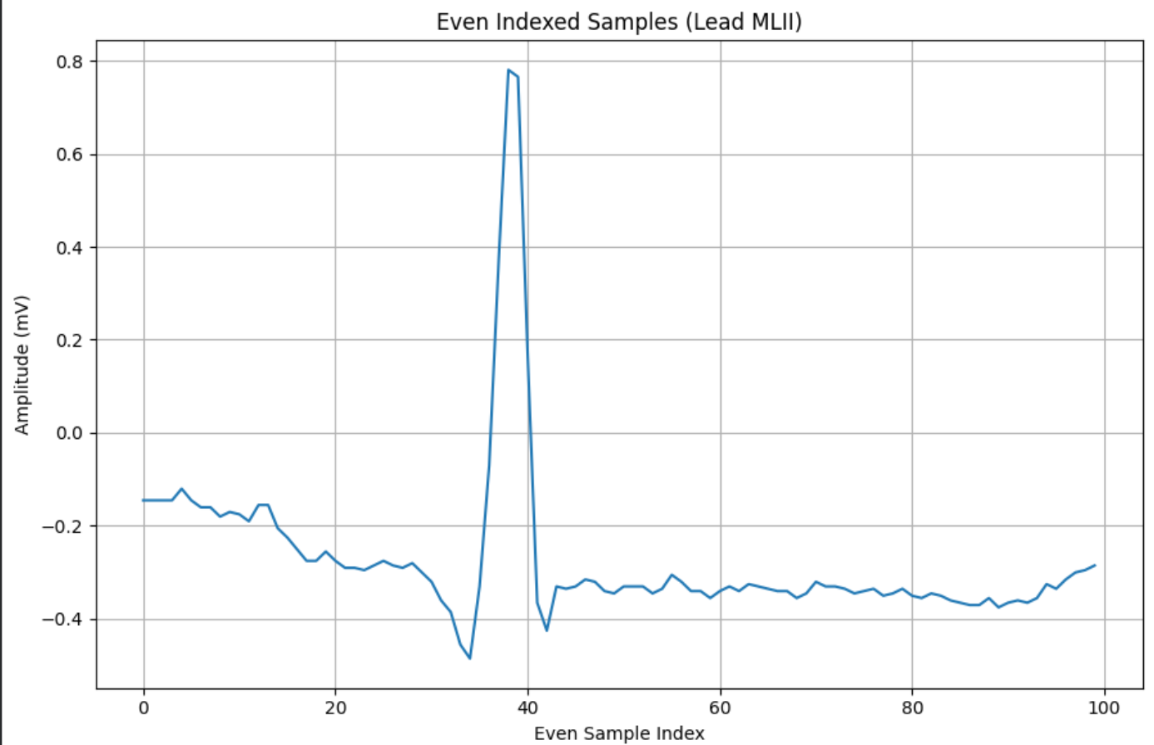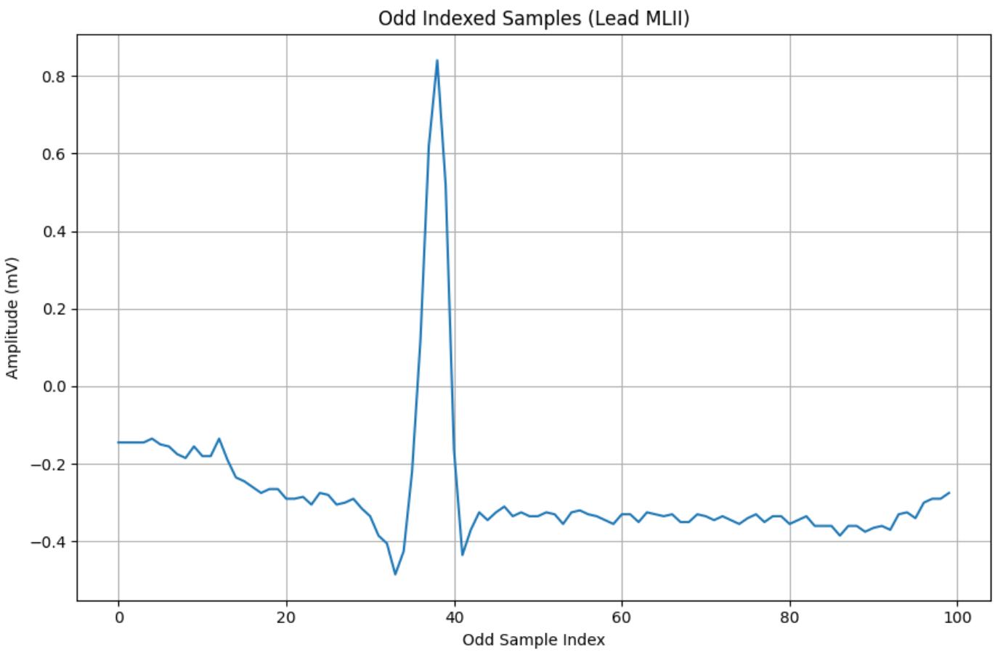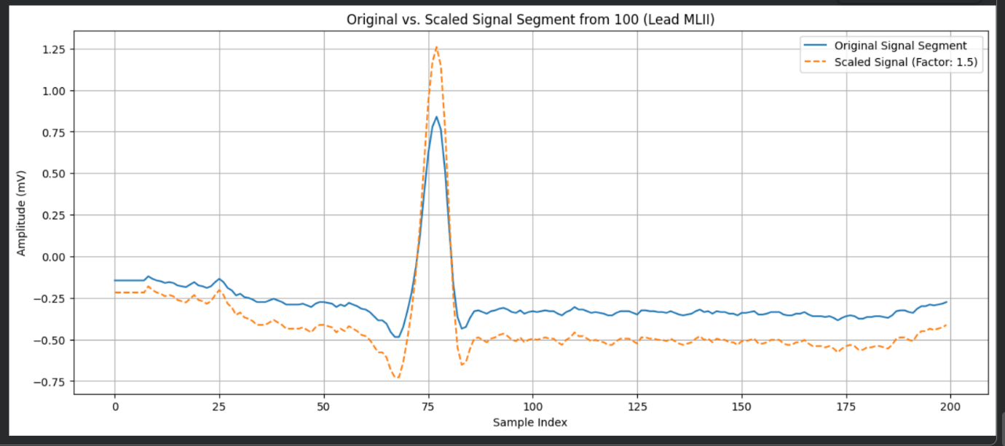
Challenges & Solutions | Selection of data,  Narrowing down sample window
Next Week Plan | More Explanation, convolution,Correlation ,Shifting , Folding , Detection
Declaraion | I hereby declare that for the assignment / academic activity submitted by me, I confirm ONE of the following statements by ticking (☐) the appropriate box:  ☐ (1) I have prepared the assignment / academic activity entirely by myself.  ☐ (2) I have completed the assignment / academic activity with academic guidance or discussion from seniors / friends / peers, while ensuring the work is my own.  ☐ (3) I have used AI-based tools only as an aid and have appropriately acknowledged or cited their use as per the ethical guidelines of the Institute.  ☐ (4) I have used AI-based tools and directly copy-pasted content for the assignment / academic activity.  ☐ (5) I have copied the assignment / academic activity from peers / friends.  I understand that selecting options (4) or (5) indicates unethical academic practice and may attract academic penalties, including rejection of the assignment or disciplinary action, as per the rules of Vidyalankar Institute of Technology, Mumbai. I submit this declaration truthfully and accept full responsibility for the same.  Student Name: Rehan Raza Shaikh Roll No.: 24105A0037  Signature: _______________________ Date: 15 july 2026

